Database:

Databases are used to store and manage large amounts of structured and unstructured data, and they can be used to support a wide range of activities, including data storage, data analysis, and data management.

Storage vs database:

Storage: database:

-cant run queries -can run queries

-no schema -schema applied

-not scalable -scalable

DBMS:

A database management system defines ,creates and maintains a database.

RDBMS:

It contains data in form of tables.

Mysql:

Is RDBMS which runs a server ,providing multiuser access to a number of databases.

Benefits:speed,reliability,ease of use.

Mysql port number:3306

Client-server interaction:

Gets results

Client program

Mysql server

Makes a request

Sql commands:

1. (DDL)Data definition language - focuses on the structure /controlling access to the data
2. (DML)Data manipulation language -for retrieving,updating data
3. (DCL)Data control language -concerns with rights,permisiions of data
4. (TCL)Transaction control language -basically used for managing and controlling the transactions in a database to maintain consistency

**DDL COMMANDS:**

**DML COMMANDS:**

Select

Update

Delete

Insert

Create

Alter

Drop

Truncate

Comment

Rename

**DCL COMMANDS:**

**TCL COMMANDS:**

Commit

Rollback

Savepoint

Set transaction

Grant

Revoke

COMMANDS:

Create database pet_adoption;

Use pet_adoption;

Create,insert,select

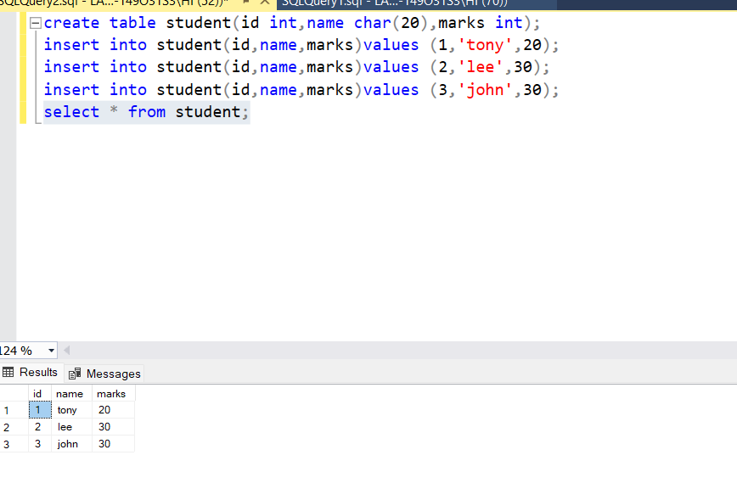

Alter (to add,delete,modify the columns)

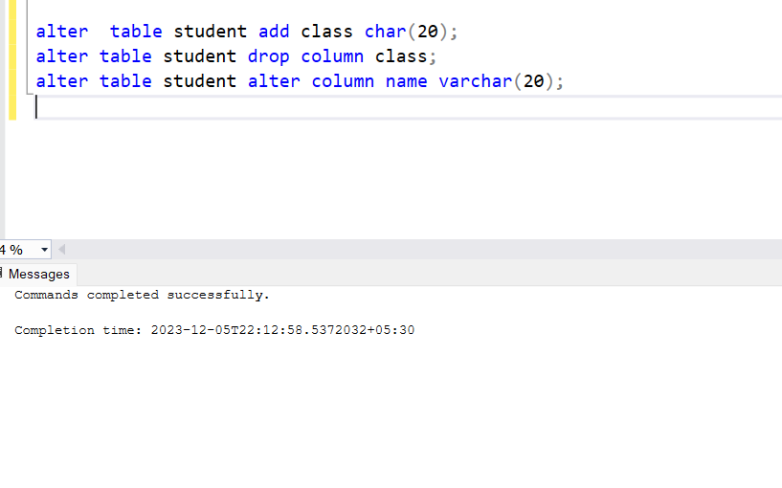

alter table animals alter column shelter int;/*modifying the datatype of already existing column*/

Update:

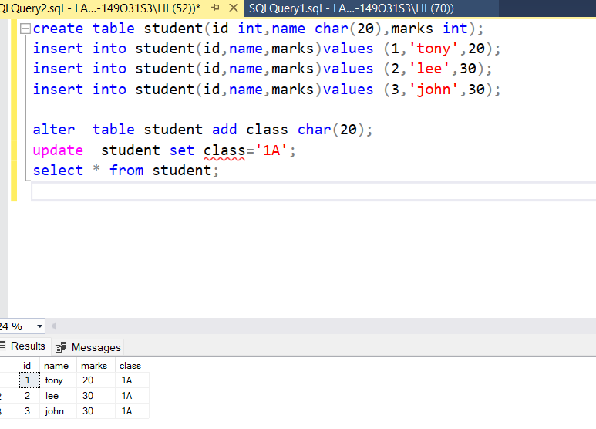

Delete:

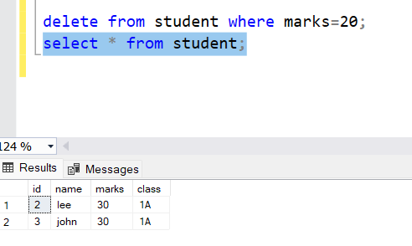

Order by:

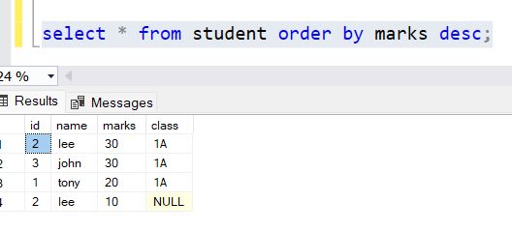

Operator:

And:

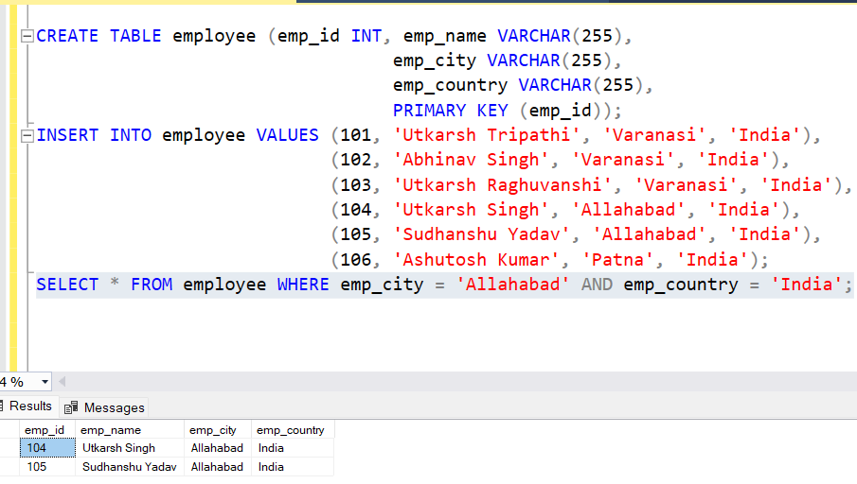

In:

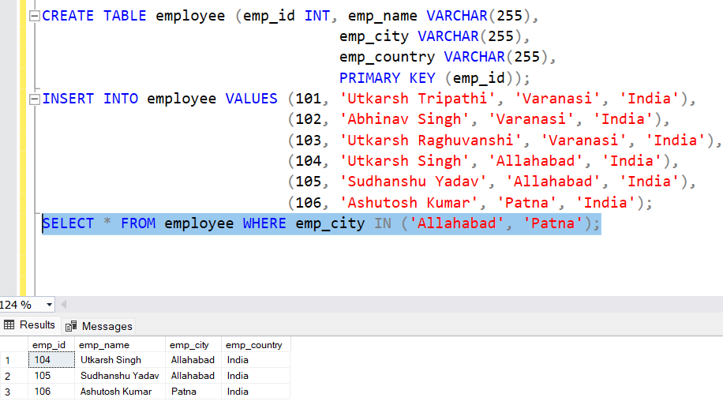

Not like,like,between,distinct:

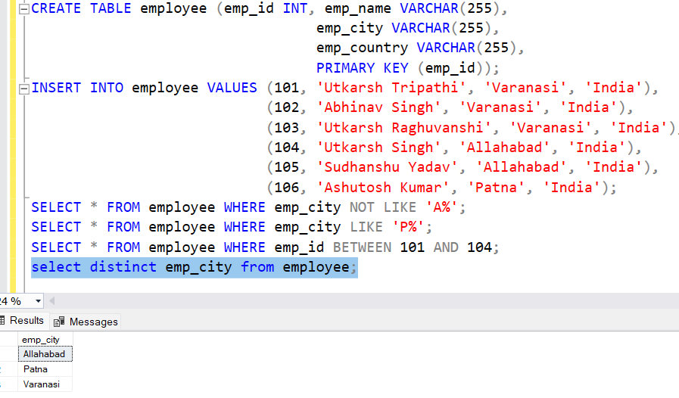

Animals table:

The ALL operator returns TRUE if all of the subqueries values matches the condition.

The ANY operator:

* It returns a boolean value as a result

1. It returns TRUE if ANY of the subquery values match the condition

